FLY AWAY

(An AIRLINE BOOKING PORTAL)

GITHUB LINK: https://github.com/AnishAugustin09/FLY-AWAY

**This document contains the:**

* Sprint Planning
* Flow of Project
* Concepts used in Project
* Working on Eclipse IDE
* Conclusion

**Sprint Planning:**

For this project, I’ve planned to complete the project in 5 Sprints. And the task is completed according to that.

**Flow of Project:**

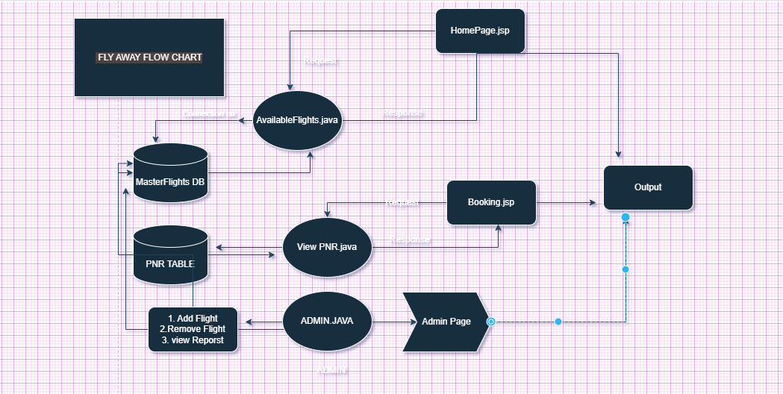

**Concepts used in Project:**

* JSP, HTML & CSS
* JAVA , SERVLET
* MYSQL

Tools & Tech used in Project:

* Eclipse IDE
* Tomcat Server 9.0
* Git & Github

**Working on Eclipse IDE:**

Step 1: Creating a new Dynamic Web Project in Eclipse

● Open Eclipse

● Go to File -> New -> Dynamic Web Project --> Next.

● Type in any project name and click on “Finish.”

● Select your project and go to WEB-INF -> New -> JSP.

● Enter JSP file name and click on “Finish.”

**Step 2:** Writing a program in JSP for the entry point of the application (**HOMEPAGE.JSP).**

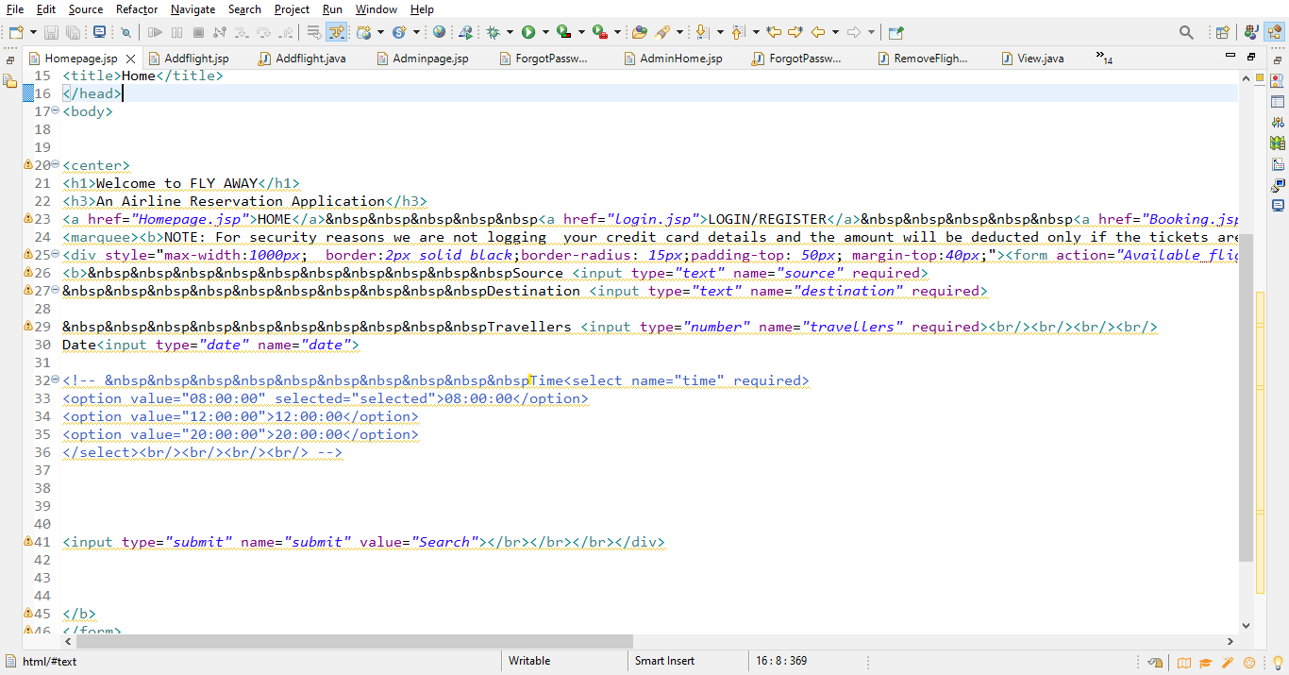

**Step 3:** Create a servlet page which get request and send response (**AVAILABLE FLIGHTS.Java**).

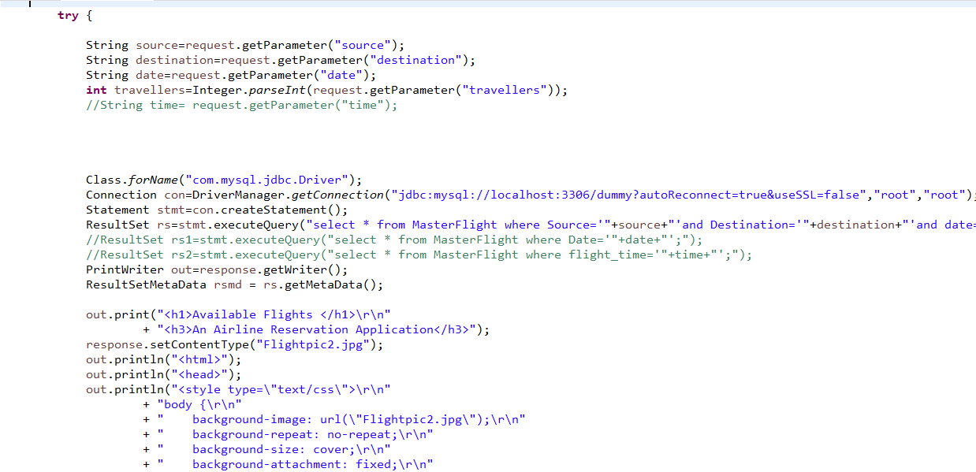

**Step 4:** Connect the JSP & SERVLET & JDBC using their requirements.

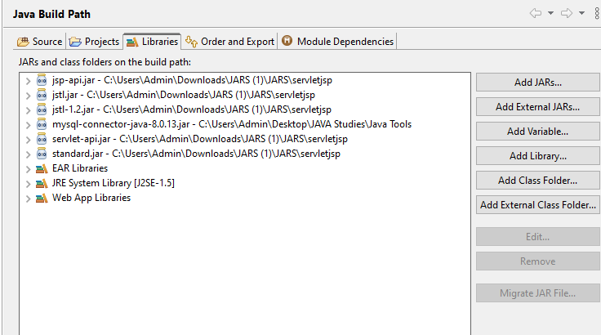

**Step 5:** Create Databases for Admin, MasterFlight, Bookings & Other specifies.

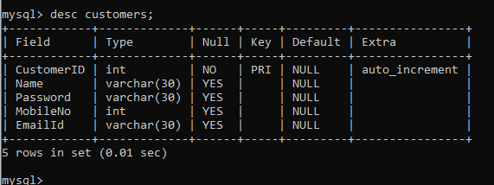

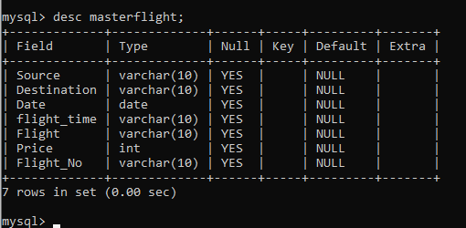

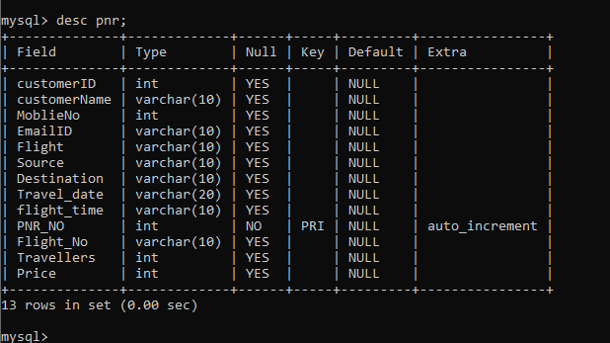

This Project was completed as per the Steps:

A search form in the homepage to allow entry of travel details, like the date of travel, source, destination, and the number of persons.

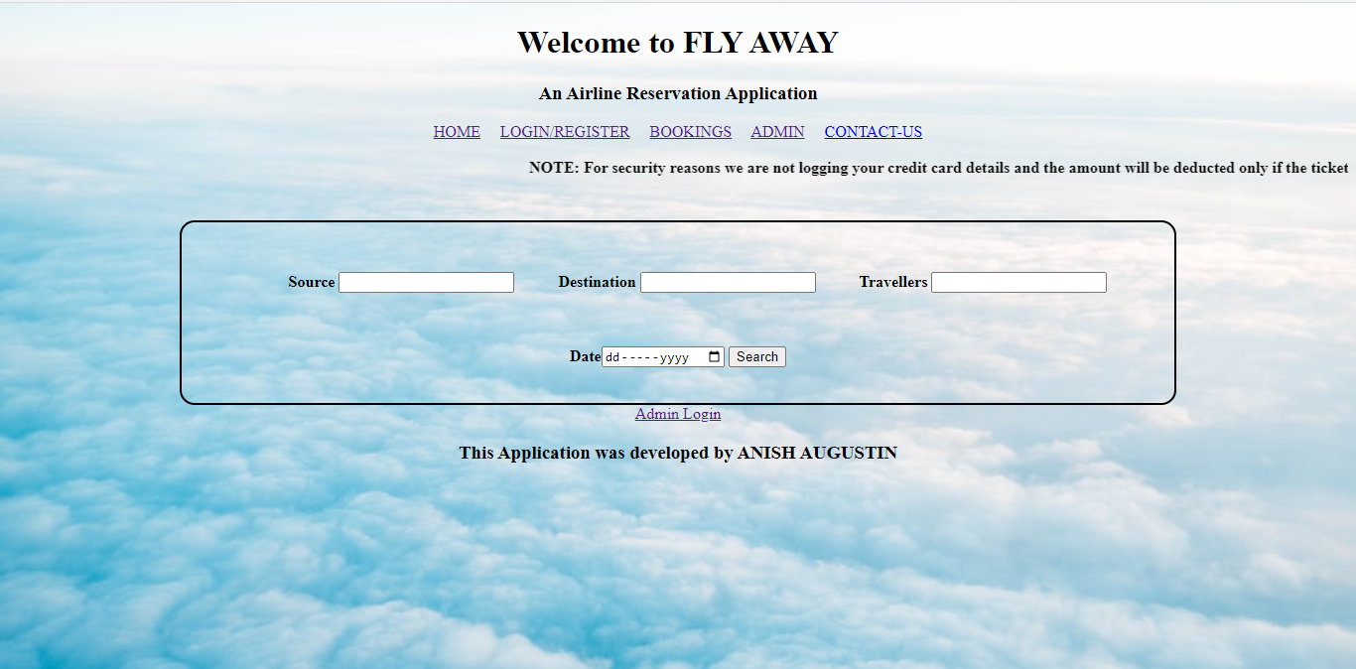

Home Page

Based on the travel details entered, it will show the available flights with their ticket prices.

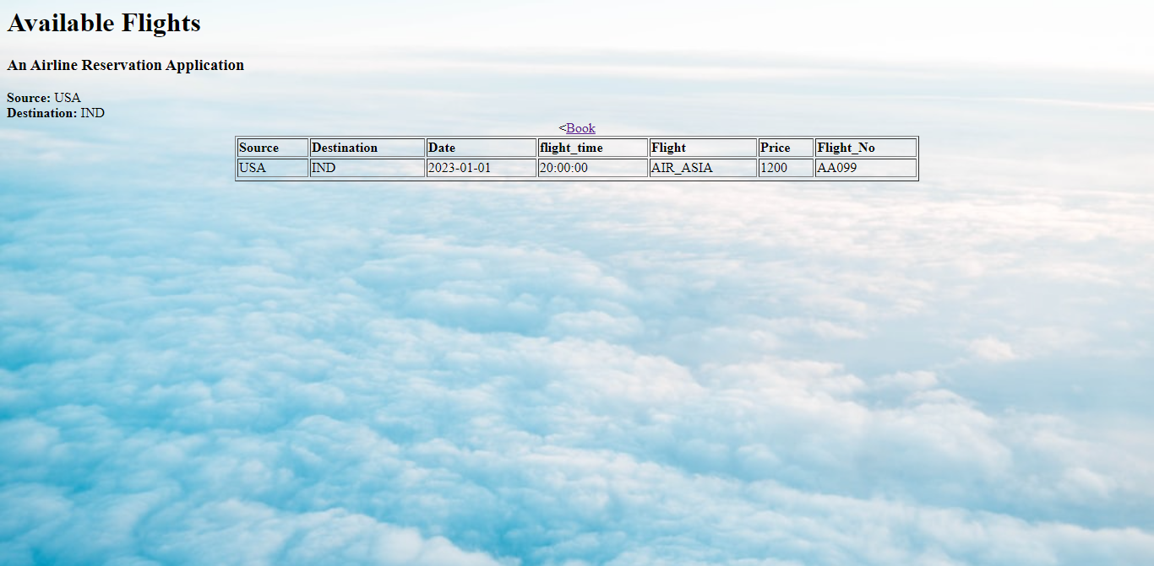

Flights based on your search

**Once a person selects a flight to book, they will be taken to a register page where they must fill in their personal details.**

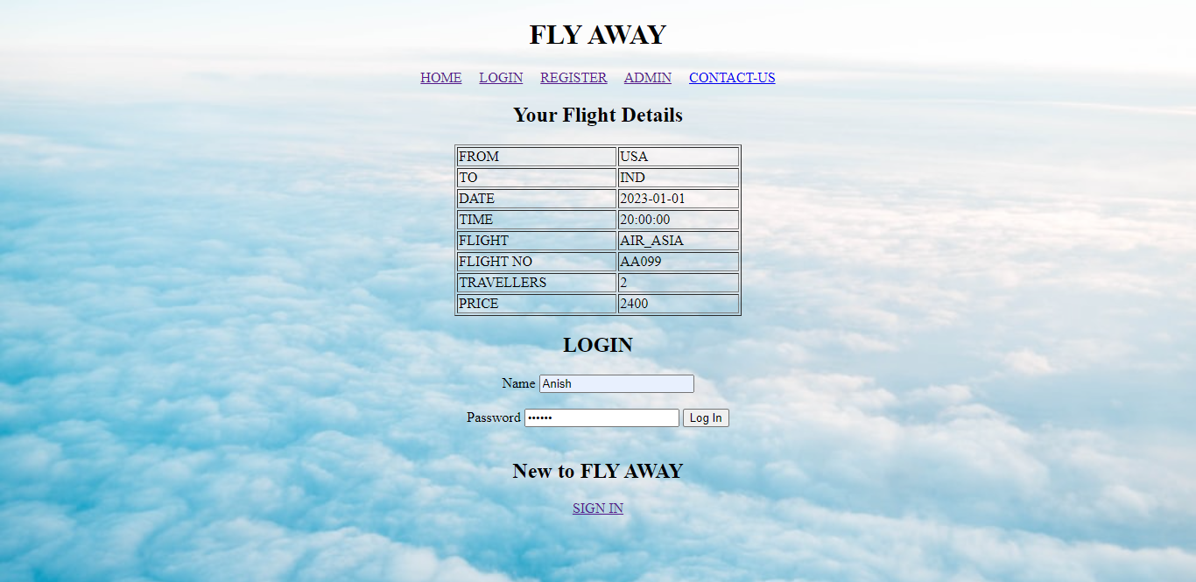

Login/Register page

In the next page, they are shown the flight details of the flight that they are booking, and the payment is done via a dummy payment gateway.

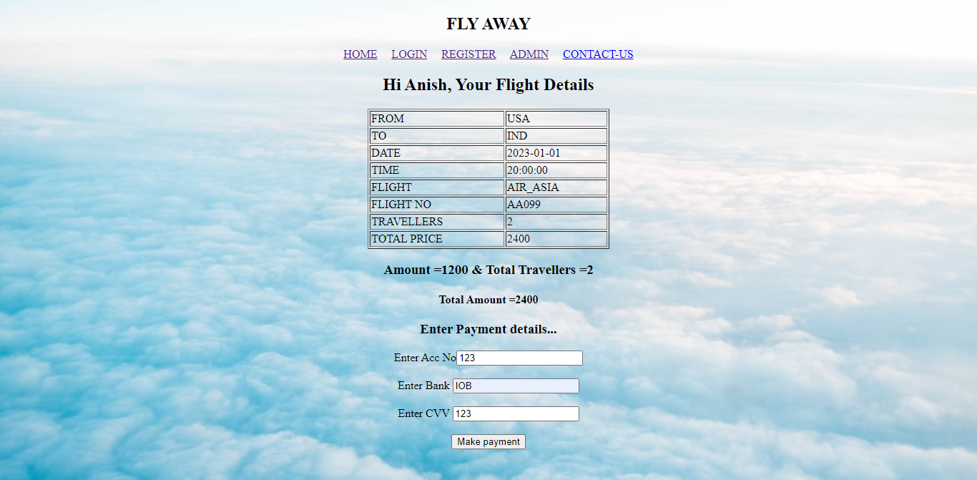

Dummy Payment page

On completion of the payment, they are shown a confirmation page with the details of the booking.

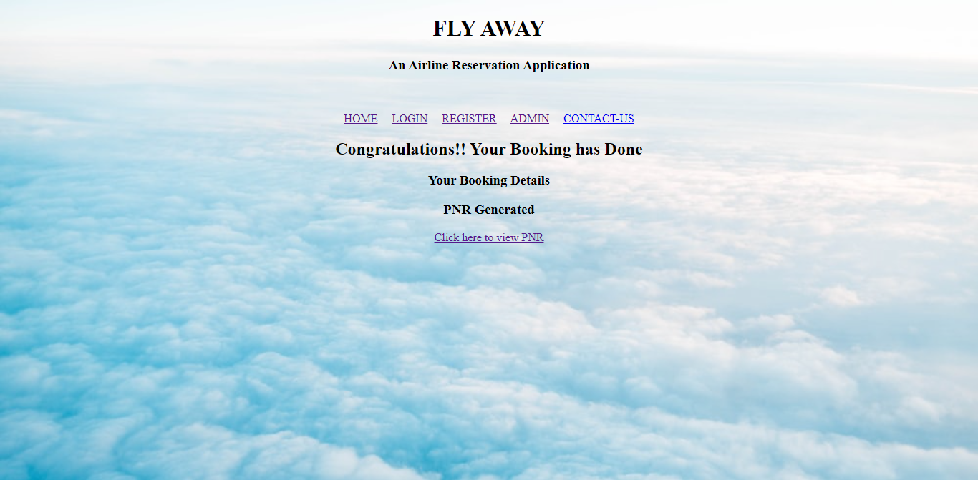

Congrats page

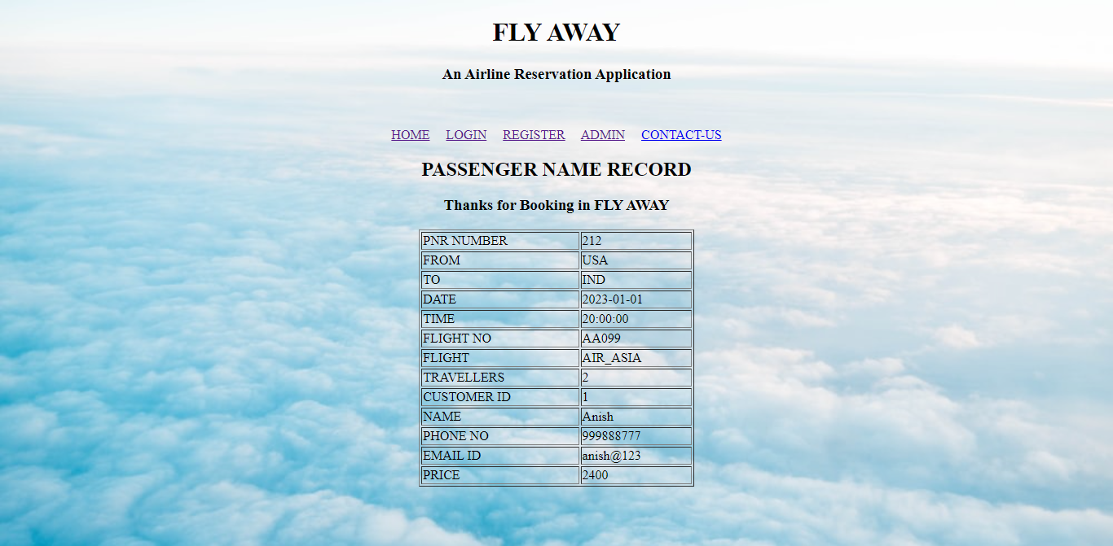

PNR page

An admin login page where the admin can change the password after login, if he wishes

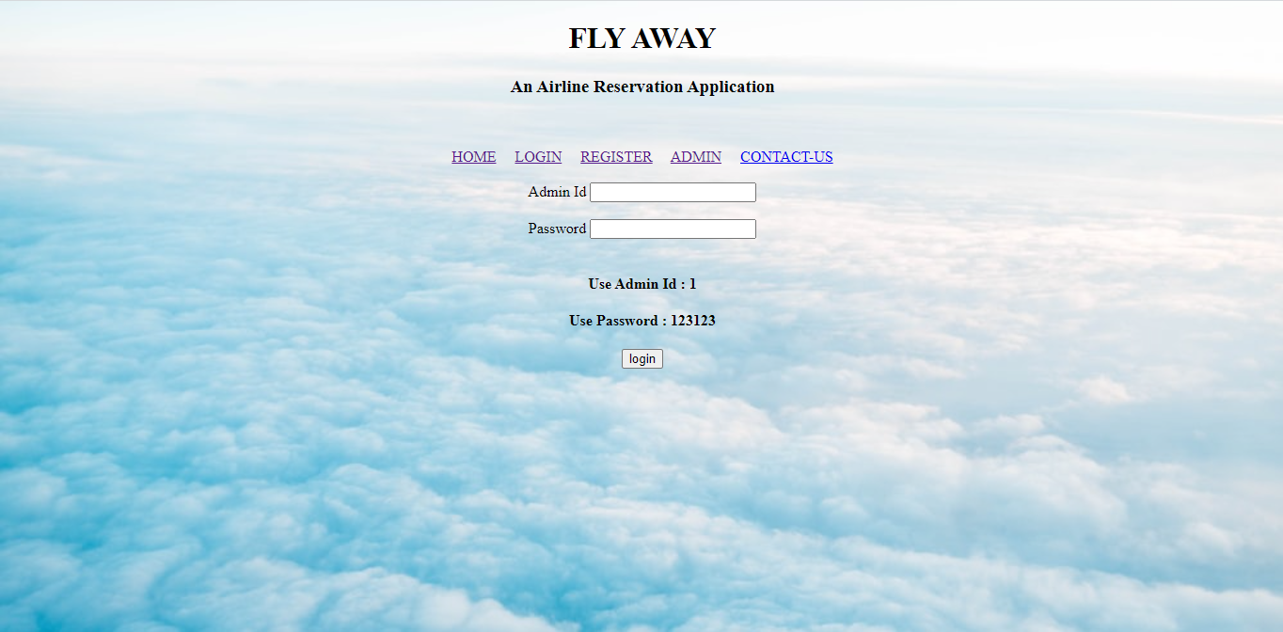

Admin login page

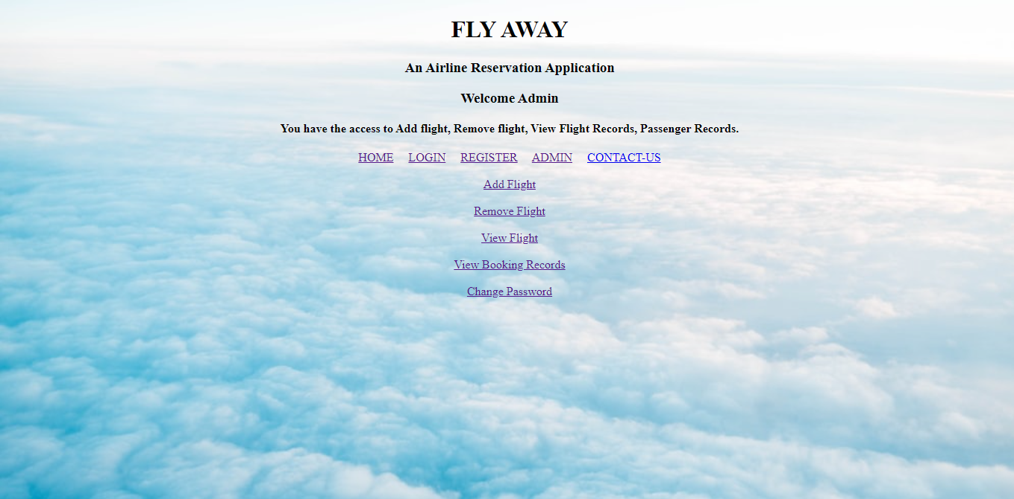

Admin control page

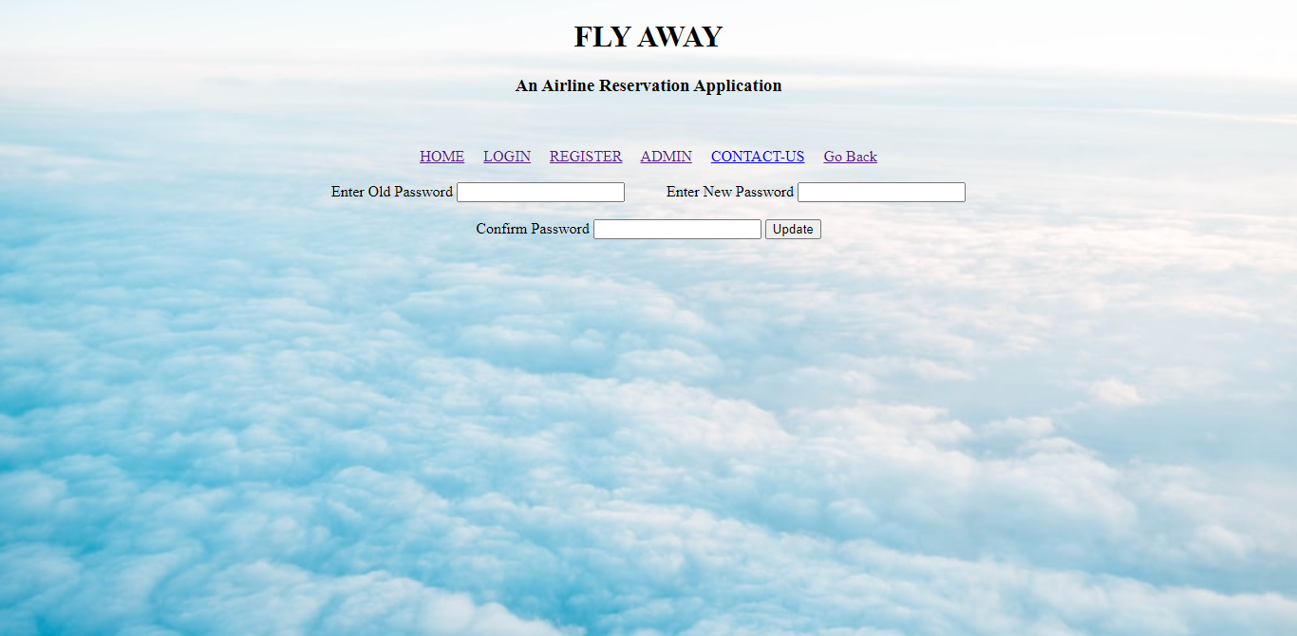

Password Change

A master list of places for source and destination

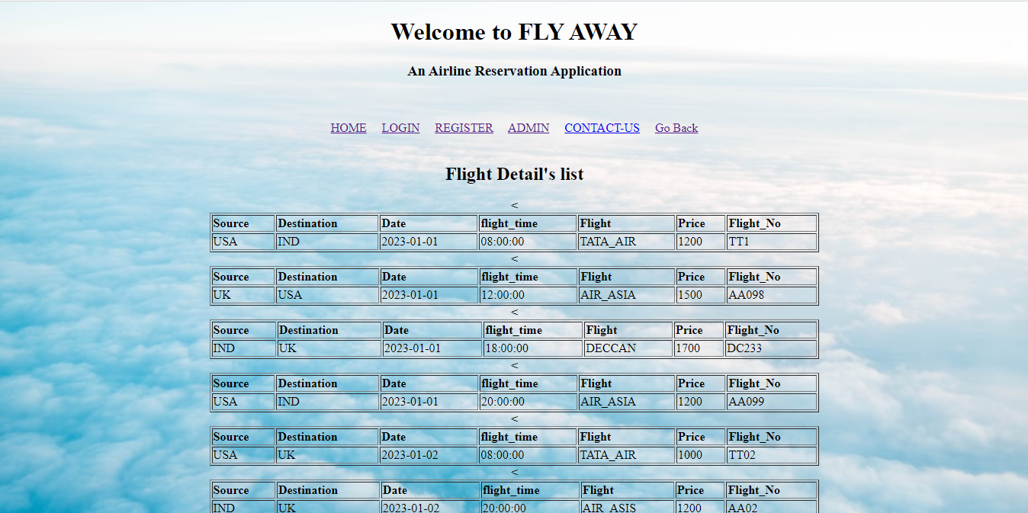

Source & Destination

A list of flights where each flight has a source, destination, airline, and ticket price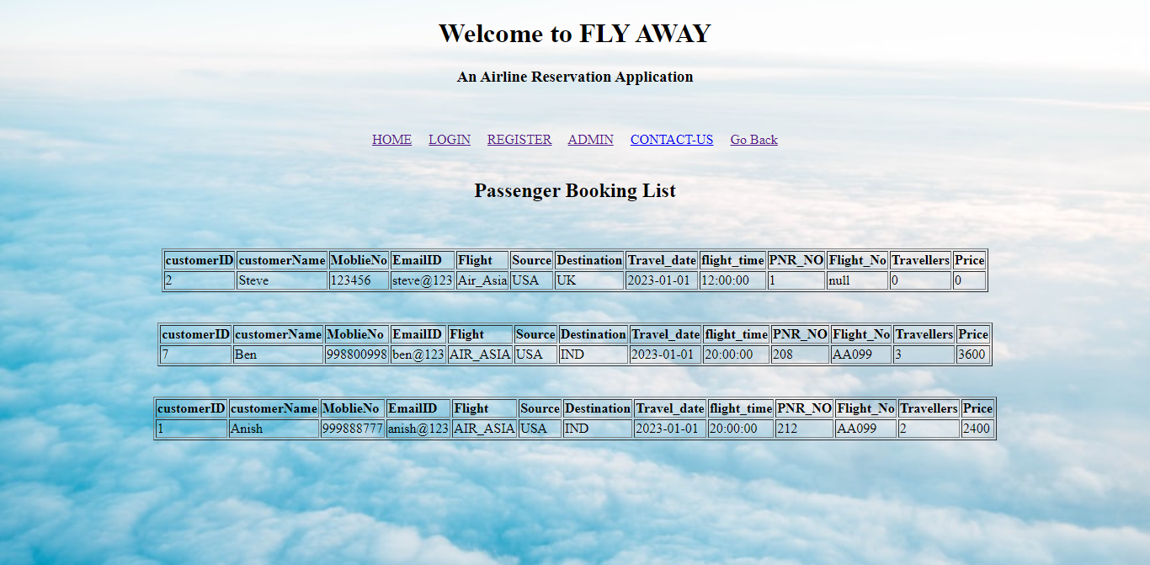

THANK YOU